Connect to Zoom Room Via Polycom

- Click Place a call
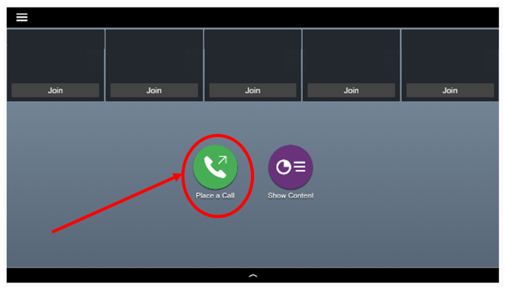

- Type in 162.255.37.11##(Meeting ID #) Please contact the assigned courtroom for the meeting id #. Please see Judges directory on the public website.

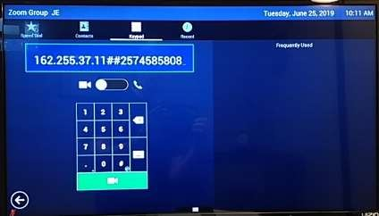
- Press call on the Polycom Hand-held Remote.
- When done, press the hang-up button on the Polycom Remote.

Connecting Zoom Via PC

- Open a Web Browser and go to Zoom.us
- Click on JOIN A MEETING
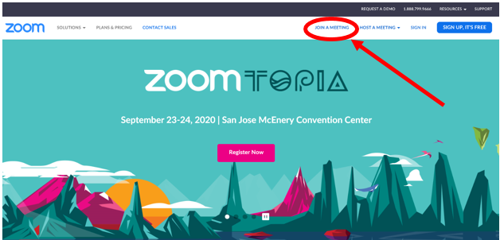
- Type in the Meeting Rm #
- Click Join
\
You are now joined in the meeting room.
- When the meeting is done, click on End Meeting

