Connecting Zoom Via PC

- Open a Web Browser and go to Zoom.us
- Click on JOIN A MEETING
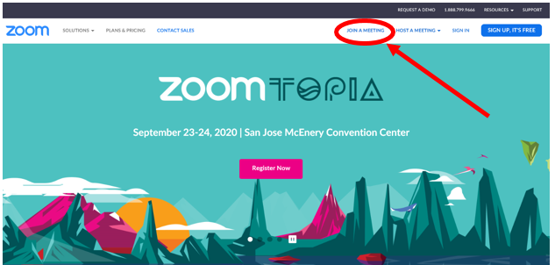
- Type in the Meeting Rm #
- Click Join
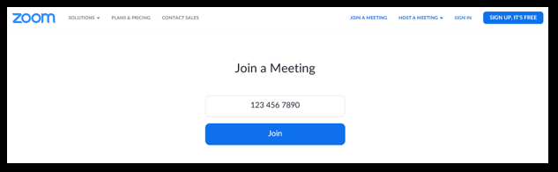\
You are now joined in the meeting room.
- When the meeting is done, click on End Meeting

